Quarterly Report – Public Page

Date of Report: 6th Quarterly Report, March 28, 2025
Contract Number: 693JK32310010POTA
Prepared for: Government Agency: DOT and Co-funders
Project Title: Standardize the Application of Vapor Corrosion Inhibitors
Prepared by: Pipeline Research Council International (PRCI), Inc.
Contact Information: Janie Norton, jnorton@prci.org 703-205-1600 ext: 105
For quarterly period ending: March 31, 2025

1: Items Completed During this Quarterly Period:

Item # | Task # | Activity/Deliverable | Title | Federal Cost | Cost Share
11 | 3 | Initiate VCI effect experiments | Summary of the VCI effect experiments initiated to be included in the quarterly report | $20,848 | $5,212
15 | 3 | Analyze coupons and corrosion probe data from the control experiments | Summary of the coupons and ER probe data results to be included in the quarterly report | $8,339 | $2,085
19 | 5 | 6th quarterly status report & project management | Submit 5th quarterly report | $7,716 | $1,929

2: Items Not Completed During this Quarterly Period:

Item # | Task # | Activity/Deliverable | Title | Federal Cost | Cost Share
14 | 3 | Initiate VCI migration experiments | Summary of the VCI migration experiments to be included in the quarterly report | $20,848 | $5,212
17 | 3 | Analyze corrosion probe data from the VCI effect experiments | Results to be included in the quarterly report | $3,127 | $782
18 | 4 | Start developing the VCI application best practice guidance | Summary to be included in the quarterly report | $6,254 | $1,564

3: Project Financial Tracking During this Quarterly Period:

Note that this chart reflects Federal share only:
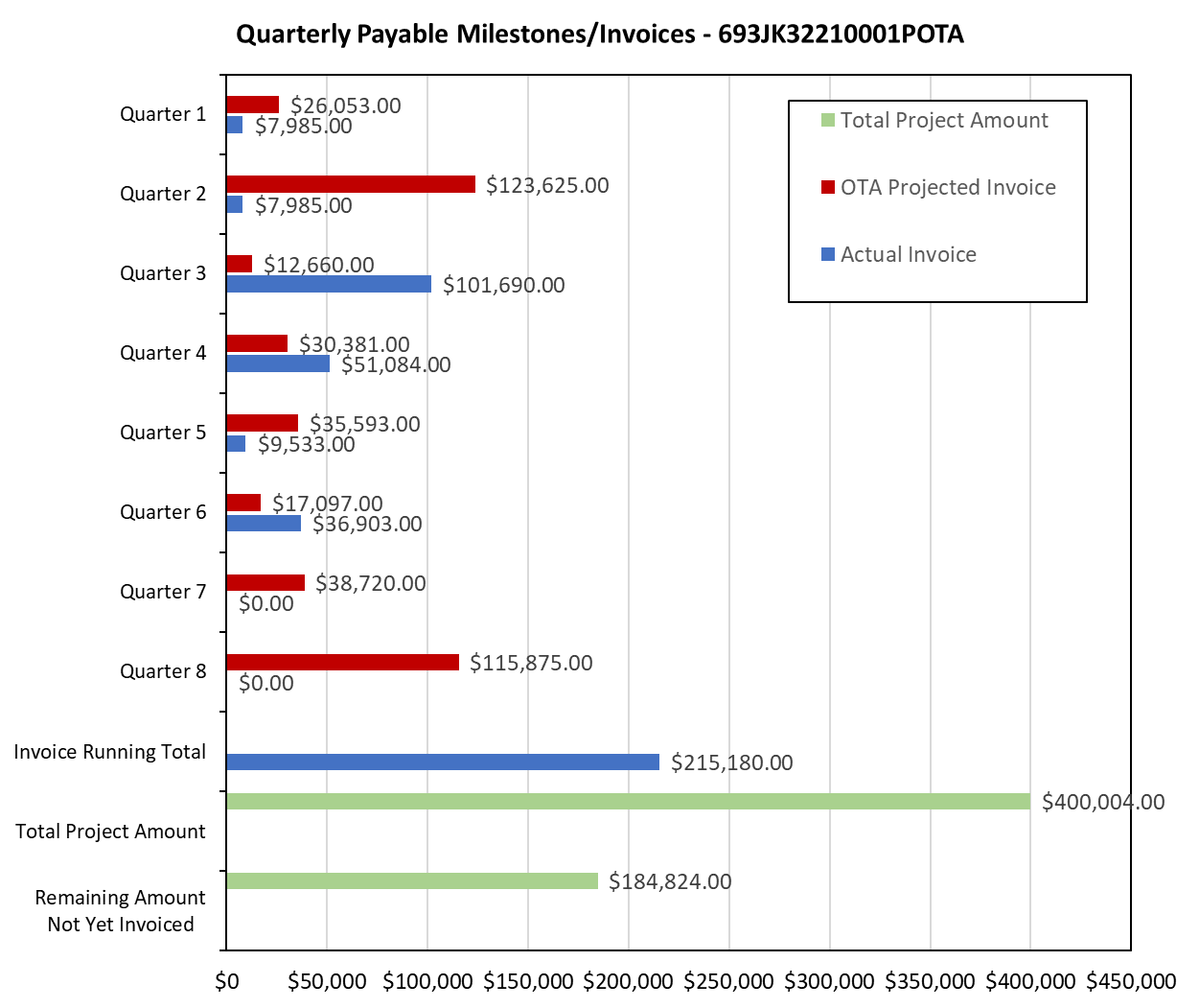

4: Project Technical Status –

Item 11, Task 3 ⎯ Initiate VCI effect experiments. Summary of the VCI effect experiments initiated to be included in the quarterly report: A total of twenty-four VCI effect experiments were started this quarter. The VCI effect experiments were started at the chloride contents of 30 and 300 ppm and moisture contents of 50 and 75% of the saturation. For each combination of the chloride and moisture, three replicate experiments were initiated. In addition, one intermittent contact experiment was initiated for each combination of chloride and moisture level. The experiments are being conducted with two VCI chemistries. Thus, a total of thirty-two VCI effect experiments are being conducted. This activity links to item 6 in Attachment 1 Team Project Activities. This activity links to item 7 in Attachment 2 Project Deliverables.

Item 15, Task 3 ⎯ Analyze coupons and corrosion probe data from the control experiments. Summary of the coupons and ER probe data results to be included in the quarterly report: The control experiments were completed this quarter. The weight-loss coupon corrosion rate data is listed in

A total of twenty-four VCI effect experiments were started this quarter. The control experiments were conducted at the chloride contents of 10, 30 and 300 ppm and moisture contents of 25, 50 and 75% of the saturation. For each combination of the chloride and moisture, three replicate experiments were conducted. The weight-loss corrosion rate data, for the continuous contact of the coupons and ER probe, are listed in Table 1. Similarly, the weight-loss corrosion rate data, for the intermittent contact of the coupons, are listed in Table 2.

Table 1. Corrosion Rate Data for Continuous Contact Coupons and ER Probes in the Control Experiments
Water Saturation Level (%) | Chloride  (ppm) | Weight-Loss Corrosion Rate + Standard Deviation  (mpy) | ER Probe derived Corrosion Rate (mpy) | Deepest Pit Corrosion Rate + Standard Deviation  (mpy)
25 | 10 | 4.7 ± 2.5 | 0.7 | 30.1 ± 13.5
25 | 30 | 6.4 ± 4.3 | 1.0 | 47.6 ± 23.7
25 | 300 | 5.7 ± 1.5 | 3.1 | 38.4 ± 9.2
50 | 10 | 3.1 ± 0.9 | 0.3 | 28.6 ± 9.0
50 | 30 | 5.1 ± 3.6 | 1.7 | 46.3 ± 27.0
50 | 300 | 6.4 ± 2.0 | 3.6 | 56.0 ± 18.1
75 | 10 | 2.3 ± 0.7 | 0.5 | 33.5 ± 18.9
75 | 30 | 3.5 ± 1.2 | 0.7 | 42.0 ± 22.2
75 | 300 | 7.2 ± 1.1 | 3.3 | 69.1 ± 14.5

Table 2. Corrosion Rate Data for Intermittent Contact Coupons in the Control Experiments
Water Saturation Level (%) | Chloride  (ppm) | Weight-Loss Corrosion Rate + Standard Deviation (mpy) | Deepest Pit Corrosion Rate + Standard Deviation  (mpy)
25 | 10 | 3.5 ± 0.2 | 22.4 ± 3.9
25 | 30 | 4.6 ± 0.7 | 34.5 ± 8.7
25 | 300 | 7.0 ± 0.5 | 35.9 ± 6.7
50 | 10 | 4.6 ± 1.2 | 24.4 ± 3.4
50 | 30 | 3.8 ± 0.4 | 41.1 ± 5.9
50 | 300 | 9.2 ± 0.8 | 60.1 ± 10.9
75 | 10 | 6.0 ± 0.8 | 36.7 ± 8.7
75 | 30 | 7.8 ± 2.6 | 39.7 ± 4.8
75 | 300 | 12.5 ± 5.0 | 73.7 ± 16.5

The following results are derived from the data listed in Tables 1 and 2:

- The chloride level of even 10 ppm was found to quite corrosive at all water saturation levels.
- The chloride levels of 30 and 300 ppm are more corrosive compared to 10 ppm level.
- The intermittent contact coupons corroded as much as constant contact coupons.
- The ER probe corrosion rates were lower than the coupon corrosion rates.

This activity links to item 7 in Attachment 1 Team Project Activities. This activity links to item 10 in Attachment 2 Project Deliverables.

Item 19, Task 5 ⎯ 6th quarterly status report & project management. Submit 6th quarterly report: The sixth quarter meeting was held on March 19, 2025. This report satisfies this item. This activity links to items 11 and 13 in Attachment 1 Team Project Activities. This activity links to item 13 in Attachment 2 Project Deliverables.

5: Project Schedule –

Item 14, Task 3 ⎯ Initiate VCI migration experiments. Summary of the VCI migration experiments to be included in the quarterly report: Preparation has been made to assemble the test setup for the VCI migration experiments. The VCI migration experiments will be started early in the next quarter, i.e., 7th quarter.

Item 17, Task 3 ⎯ Analyze coupons and corrosion probe data from the VCI effect experiments. Results to be included in the quarterly report: The VCI effect experiments were started towards the end of 6th quarter. Approximately two months of data is needed to have a meaningful analysis. This item will be undertaken in the next quarter, i.e., 7th quarter.

Item 18, Task 4 ⎯ Start developing the VCI application best practice guidance. Summary to be included in the quarterly report: The project team had to expend considerable effort in analyzing the control test coupons and initiating the VCI migration tests. This item will be undertaken in the next quarter, i.e., 7th quarter.

The project is behind schedule. The project team plans to catch up as much as possible in the next quarter. A 10-month no-cost extension will be submitted early next quarter.

